US ^{How To:}
UniqueSchools
App Notice Board
This is a great feature to communicate with Students/ Parents/ Staff. You decide on a group-by-group basis who will have access to respond to messages, so it can work as either a Chat or a Notice Board but there is no access to mobile numbers or email addresses.
Only staff members can create groups, so you will never be added by a student or a parent to a group.
If a staff member has Limited Access to the App they are still able to have Full Access to a specific Notice Board.
To create your Notice Board go to your Unique dashboard and tap on Notice Boards. Then tap in ADD to create a new one.
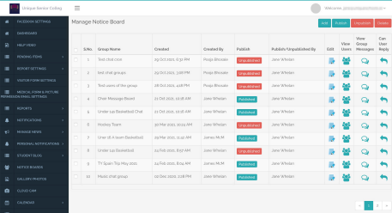next page
How To: Notice Board / 2
A) Enter the title of your Notice Board.
B) Select Filter - either an existing Group, or find your Students.
C) Select the Years and Class you would like to add to your Group
D) Select Students/Parents individually or ALL Students/Parents.
E) After selecting the students/parents click ‘ADD Selected’ to your Final List.
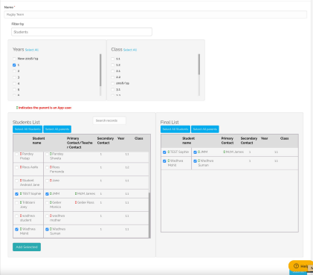
A
B
C
D
E
next page
How To: Notice Board / 3
A) After creating your Final List of Students/Parents, you can change the Filter by to create a list of Teachers in the group.
B) Select all Staff Members you would like to have in your group and click ‘Add Selected’ to enter into Final List.
C) Click Submit.
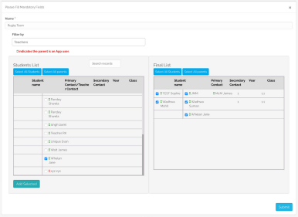
A
B
C
next page
How To: Notice Board / 4
It takes a couple of seconds to load your group. Once it's ready, tap on ‘Can User Reply’ icon in order to give users access to respond to messages.
By default no one has access to reply.
Tap on the ‘Can User Reply’ icon to open pop-up window which shows the names of everyone added to your Group. (This will only show App Users.)
You can either Allow All or Select who you wish to give access to respond and then select ‘Allow’.
